**“Java Constructur”**

Faishal Hanif Ramadhani – 14 – X RPL 4

1. Constructor #1

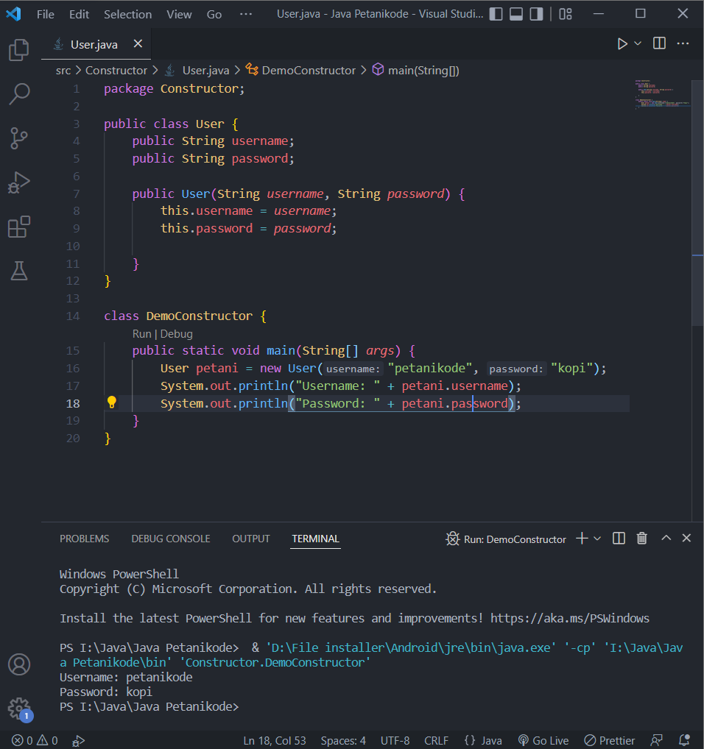

1. Constructor #2:

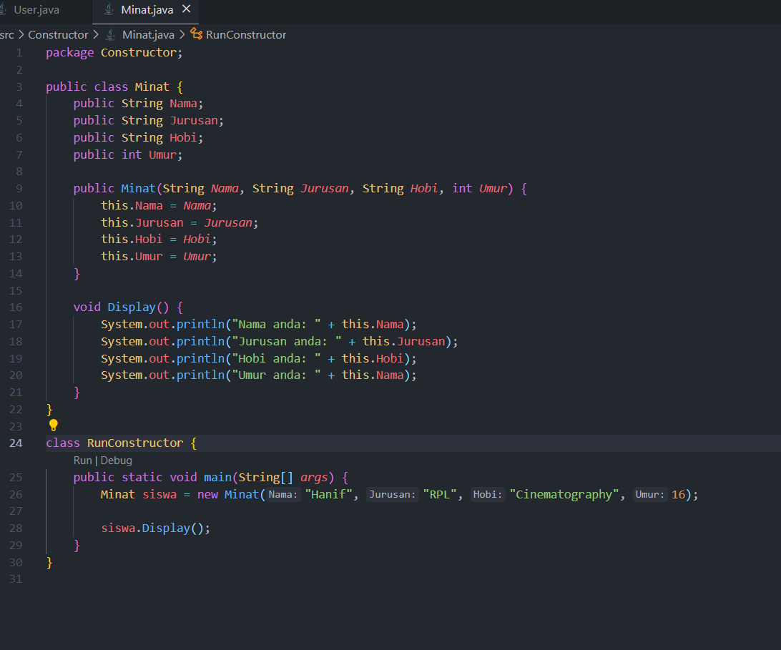

Output #2:

